Algorithms and Programming I
LAB 7
Exercises

1- Write a program that finds the maximum value of the matrix.

Note: Don’t take the values of arrays from the user. Assign them in the code.


Example:
int[,] a = new int[,] {{4, 4, 7, 2, 9, 12},
{0, 5, 7, 16, 3, 5},
{2, 3, 6, 3, 2, 10}};
Output: 16

2- Write a program that exchanges “Izmir” values with “Istanbul” and “Istanbul” values with “Izmir” in the same array.

Note: Don’t take the values of arrays from the user. Assign them in the code.


Example:
Member_ID | Name | City | Age
M001 | Ali Taş | Izmir | 40
M002 | Ebru Kaya | Ankara | 25
M003 | Ayşe Saray | Bursa | 15
M004 | Ece Nazar | Istanbul | 60
M005 | Ege Tarak | Izmir | 45
M006 | Can Ak | Antalya | 85
M007 | Sibel Tan | Istanbul | 19

string[,] myarray = new string[,] {{"M001","Ali Taş","Izmir", "40"},
{"M002","Ebru Kaya","Ankara", "25"},
{"M003","Ayşe Saray", "Bursa", "15"},
{"M004","Ece Nazar","Istanbul", "60"},
{"M005","Ege Tarak","Izmir ", "45"},
{"M006","Can Ak","Antalya", "85"},
{"M007","Sibel Tan","Istanbul ", "19"}};

Output (myarray):
{{"M001","Ali Taş","Istanbul", "40"},
{"M002","Ebru Kaya","Ankara", "25"},
{"M003","Ayşe Saray", "Bursa", "15"},
{"M004","Ece Nazar","Izmir", "60"},
{"M005","Ege Tarak","Istanbul", "45"},
{"M006","Can Ak","Antalya", "85"},
{"M007","Sibel Tan","Izmir", "19"}}

3- Write a program that finds a given matrix is a zero-one matrix or not. The program should print true or false.

Zero-one matrix is a matrix with elements which are either 0 or 1.

Note: Don’t take the values of arrays from the user. Assign them in the code.

Example:

Input:
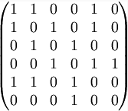
Output: true

Example:
int[,] a = new int[,] {{1, 0, 0, 1, 0},
{0, 0, 9, 0, 0},
{0, 0, 1, 1, 0},
{0, 0, 0, 0, 1},
{0, 0, 1, 0, 0}};
Output: false
4- Write a program that determines a matrix is an upper triangular matrix or not.

An upper triangle matrix is a square matrix in which the entries below the diagonal are all zero.

Examples:
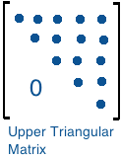
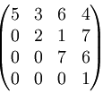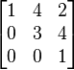

int[,] a = new int[,] {{1, 7, 9, 1, 1},
{0, 8, 7, 1, 2},
{0, 0, 1, 9, 3},
{0, 0, 0, 2, 1},
{0, 0, 0, 0, 5}};
Output: true

int[,] a = new int[,] {{1, 6, 0, 1, 0},
{0, 0, 9, 0, 0},
{0, 0, 2, 8, 0},
{0, 0, 0, 0, 1},
{0, 0, 8, 0, 5}};
Output: false

5- Write a program that controls the placement of the queens.

The matrix should be a square matrix (N-by-N) so that no two queens are in the same row or column.

Example:

{{‘*’,’*’,’*’,’Q’,’*’},

{‘*’,’Q’,’*’,’*’,’*’},
{‘*’,’*’,’*’,’*’,’Q’},
{‘*’,’*’,’Q’,’*’,’*’},
{‘Q’,’*’,’*’,’*’,’*’}}

Output: true

* * * Q *
* Q * * *
* * * * Q
* * Q * *
Q * * * *
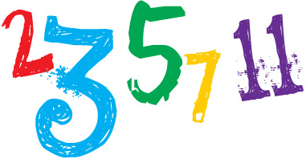
6- Write a program that takes an integer N from the user and creates an NxNxN Boolean array a[][][]
such that a[i][j][k] is true if i, j and k are prime, and false otherwise.

7- Given the positions and masses of a sequence of objects, write a program to compute their center-of-mass, or centroid. The centroid is the average position of the N objects, weighted by mass. If the positions and masses are given by (x_{i}, y_{i}, m_{i}), then the cendroid (x,y,m) is given by

m= m₁ + m₂ + …. + m_{N}
x = (m₁x₁ + …. + m_{n}x_{N}) / m
y = (m₁y₁ + …. + m_{n}y_{N}) / m

Note: Don’t take the values of arrays from the user. Assign them in the code.

Example:
int[,] a = new int[,] {{1, 5, 4},
{3, 8, 2},
{-2, 6, 3},
{4, -2, 8},
{6, -3, 6}};

Questions

Upload the answers of the following questions from http://lectures.cs.deu.edu.tr/ web site until November 22, 2015.


1- Assume that we have a game board with NxM dimensions. Some cells in the game board include diamonds, others include numbers which indicate you how many diamonds there are adjacent to that cell. The aim of the game is to fill the gaps which are represented with letters in the field.

Write a program that finds the values of the cells represented by letters in Diamond Miner Game.

Note: Don’t take the values of arrays from the user. Assign them in the code.

Examples:
{{‘Δ’,’4’,’Δ’,’Δ’,’1’,’0’,’1’,’1’,’n’},  {’Δ’,’4’,’Δ’,’k’,’4’,’2’,’2’,’Δ’,’1’},  {’2’,’3’,’m’,’Δ’,’Δ’,’Δ’,’2’,’2’,’2’},  {’1’,’Δ’,’2’,’3’,’Δ’,’3’,’1’,’1’,’Δ’}}  Δ4ΔΔ1011n  Δ4Δk422Δ1  23mΔΔΔ222  1Δ23Δ311Δ  Outputs:  k=5  m=3  n=1 | {{‘2’,’Δ’,’Δ’,’3’,’1’,’0’,’1’,’1’,’1’,’0’},  {’Δ’,’x’,’Δ’,’Δ’,’4’,’2’,’2’,’Δ’,’1’,’0’},  {’2’,’5’,’Δ’,’Δ’,’Δ’,’Δ’,’2’,’2’,’y’,’1’},  {’1’,’Δ’,’Δ’,’Δ’,’Δ’,’3’,’1’,’1’,’Δ’,’1’},  {’z’,’2’,’3’,’3’,’2’,’1’,’t’,’1’,’1’,’1’}}  2ΔΔ3101110  ΔxΔΔ422Δ10  25ΔΔΔΔ22y1  1ΔΔΔΔ311Δ1  z23321t111  Outputs:  x=5  y=2  z=1  t=0

2- Write a program that determines a matrix is a Toeplitz Matrix or not.

A Toeplitz Matrix is a matrix in which each descending diagonal from left to right is constant.

Note: Don’t take the values of arrays from the user. Assign them in the code.

Examples:
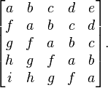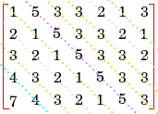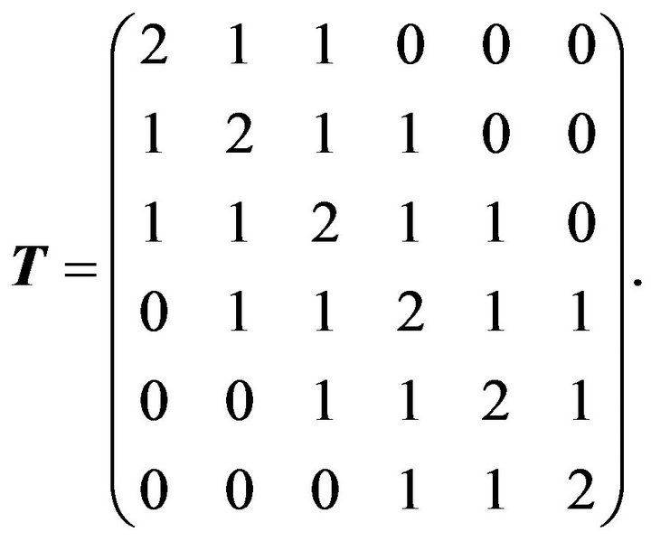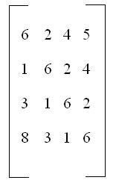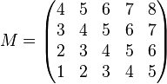

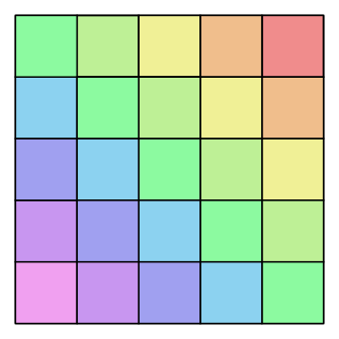
Example:
int[,] a = new int[,] {{1, 5, 3, 3, 2, 1, 3},
{2, 1, 5, 3, 3, 2, 1},
{3, 2, 1, 5, 3, 3, 2},
{4, 3, 2, 1, 5, 3, 3},
{7, 4, 3, 2, 1, 5, 3}};
Output: true

Example:
int[,] a = new int[,] {{3, 5, 8},
{2, 3, 5},
{9, 6, 3}};
Output: false

